**Resolution supporting the recognition of the legal personality and rights of the Magtogoek / Saint Lawrence River**

|  |  |  |
| --- | --- | --- |
| **WHEREAS** | The St. Lawrence River watershed plays an essential role for all forms of life by supporting a rich diversity of species and ecosystems, supplying wetlands and other aquatic habitats with water, and providing vital nutrients to coastal estuaries and to the oceans, by transporting sediment to deltas and performing other essential ecological functions; | |
| **WHEREAS** | the watershed of the St. Lawrence River plays a central role in the identity, history, culture and economy of the Nations that make up Quebec; that it contributes to the quality of life of local communities; | |
| **WHEREAS** | the St. Lawrence River watershed also has intrinsic value, independent of the benefits it provides to human and non-human populations, which must be protected from threats such as climate change and emerging pollutants; | |
| **WHEREAS** | the current legal framework, although constantly evolving, struggles to ensure sufficient protection of the St. Lawrence River and its tributaries, which are undergoing accelerated deterioration requiring immediate action [1]; | |
| **WHEREAS** | a paradigm shift must take place in order to conceive of Nature as a subject of law that must be respected, protected and preserved; | |
| **WHEREAS** | the recognition of the rights of Nature, in complementarity with the legal tools currently in place, promotes the protection of ecosystems by giving them legal personality; | |
| **WHEREAS** | the Quebec state has already recognized in *the Civil Code of Quebec* the biocentric approach under which animals are no longer objects, but are considered living beings endowed with sensitivity and biological imperatives [2]; | |
| **WHEREAS** | municipalities (e.g. the MRC of Minganie in Quebec, Mexico City (Mexico), Tamaqua Borough (PA, USA), Orange County (FL, USA), Crestone (CL, USA), Santa Monica and San Francisco (CA , USA), among others, territories (e.g. Victoria in Australia and Colima, Oaxaca and Guerrero in Mexico), countries (e.g. Ecuador, Bolivia and Aotearoa/New Zealand) and other jurisdictions around the world have recognized the legal status and rights of Nature [3]for natural entities and ecosystems such as rivers; | |
| **WHEREAS** | the *International Observatory for the Rights of Nature* in partnership with *Eau Secours* , *Stratégies Saint-Laurent, le Semoir, Arbre-Évolution* and several partners from various backgrounds are building an *Alliance around the St. Lawrence River and its watershed* , with the aim of propose a law that will recognize the legal personality of this ecosystem; | |
| **WHEREAS** | municipalities are key players in the protection of water, the environment and biodiversity who can participate in the transformation of the structures at the origin of climate change and the degradation of ecosystems in order to ensure a healthy environment and ecologically balanced to respect the rights of current and future generations; | |
| **WHEREAS** | To enable municipalities to carry out this mission, and to offer an adequate quality of life and work, it is essential to remedy the lack of investment in public drinking water treatment and sanitation services so that they meet environmental and water quality requirements; | |
| **For these reasons** |  | |
| **BE IT RESOLVED** | |  |
| **THAT** | The ______________________________________________________ supports the efforts of the International Observatory for the Rights of Nature and joins the St. Lawrence Alliance, aiming to recognize the legal personality and rights of the St. Lawrence River and its watershed including its tributaries; | |
| **THAT** | hereby, the _____________________________________________________ expresses its support for the request of government authorities to request the recognition of a new status for the St. Lawrence River and its watershed, that of subject of law; | |
| **THAT**  **THAT** | the ______________________________________________________ recognizes that protecting the rights of the St. Lawrence River and its watershed requires prioritizing investment in public infrastructure to clean up wastewater and adequately treat drinking water;  the protection of the River and the tributaries must be ensured by Guardians, representing the realities of the different riparian communities, who will have the duty to act in the name of the rights and interests of the River and the tributaries, to ensure the protection of their rights fundamentals; | |
| **THAT** | the _______________________________________________________ underlines the importance that municipalities be supported and adequately financed to guarantee both respect for the rights of the St. Lawrence River and its tributaries, as well as respect for the right to a healthy environment, as well as the human right to water and sanitation. | |

Date

Place

Signature

Firstname name

Title

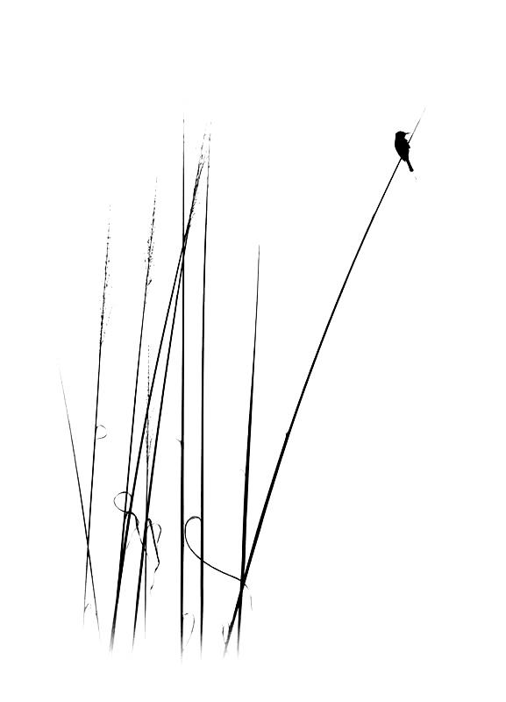

1. Ministry of the Environment and the Fight against Climate Change. 2021. The St. Lawrence. <https://www.environnement.gouv.qc.ca/eau/flrivlac/fleuve.htm>
2. Civil Code of Quebec, article 898.1; See also this recent judgment of the Superior Court of Quebec (our emphasis): Walsh v. Dandurand, 2019 QCCS 1403 (CanLII), <http://canlii.ca/t/hztk2>:
3. See the Constitution of Ecuador (2008), art. 10, 71, 72, 73 and 74; *Bolivian Framework Law (071) on the Rights of Mother Earth* (2010); *Bolivian framework law (300) of Mother Earth and development for a good life* (2012); *Te Awa Tupua (Whanganui River Claims Settlement) Act* (2017), New Zealand; *Yarra River Protection Act* (2017), Victoria, Australia; Constitution of the City of Mexico, art. 18 (2018); Constitution of the State of Colima, Mexico (2019); Ordinance 2013-01 of Mora County, New Mexico (2013); *Ordinance of the City Council of the City of Santa Monica Establishing Sustainability Rights* , Santa Monica, California (2013); Resolution 006-2018, Crestone, Colorado (2018); *Resolution 397-14 on the rights of whales and dolphins* , San Francisco, California (2014); Republic of Uganda, *National Environment Act, 2019* , s. 4.